# **CentOS**

* 1. Install Virtual Box <https://www.virtualbox.org/wiki/Downloads>
  2. To install click either one of the following links and follow the instructions there. For example, here’s what you do to install Virtual BoxA white background with black text

     Description automatically generated
  3. Upon clicking the link that pertains to your OS, the download will start. Make sure to remember where you put your installation file.
  4. A screenshot of a computer

     Description automatically generated
  5. For example, the screenshot above is an example of where I put my vbox installation file.
  6. Upon selecting the installation file, here is an example of the message you should see.
  7. A screenshot of a computer

     Description automatically generated
  8. Upon the next step of the installation is to select the way you want features to be installed. Take the default options and just go ahead with the installation unless you know exactly what you’re doing with modifying the features. This is what the next 2 screens should look like:

* 1. A screenshot of a computer program

     Description automatically generated
  2. The next screen will show the installation process.A screenshot of a box

     Description automatically generated
  3. Here’s how to install cent os: <https://www.centos.org/download/> make sure to select x86_64
  4. A screenshot of a computer

     Description automatically generated
  5. 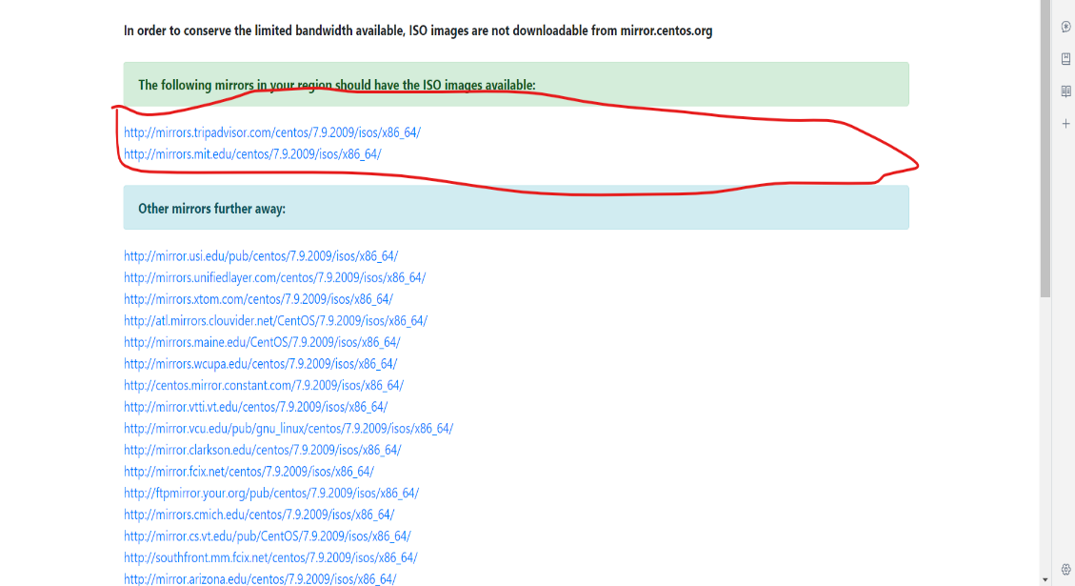
  6. Navigate to where you downloaded the iso file and select it as the iso image as shown below!
  7. The next screen upon selecting the links should look something like this:

* 1. Select the everything 2009.iso file and make sure you know where you put the download. On the screenshot below, for example, I put the file in the same place as my vbox installation file. The files with the red x’s are the VM server iso files.A screenshot of a computer

     Description automatically generated
  2. Back on Virtual Box, you will now select the “new” button to start creating the virtual machine.
  3. As you can see here, the next 2 screenshots you see include typing in the name of your VM that you would like to see on your screen after VM creation. You will also be configuring your folder directory. I would just leave it as is. Really the important part here is making sure you know what the ISO image is for CentOS or any other VMs you end up creating in the future.
  4. The next step is making your username and password for the VM as well as your hostname. Check the box for guest additions ISO as it will do things like include shared folder support between host and guest operating systems. A screenshot of a computer

     Description automatically generatedA screenshot of a computer

     Description automatically generated
  5. Take the default base memory and processors and everything else from this point on. Leave the settings as default from this point on unless you know exactly what you’re doing with these settings. A screenshot of a computer

     Description automatically generated

* 1. Here is the screen you will see upon clicking the start button for the VM’s. For reference, this is where the start button is:
  2. A screenshot of a computer

     Description automatically generated
  3. Here is the screenshot for the first screen you will see when you press the green start button. Select the “Install CentOS 7” by pressing enter. At this point, you can only use arrow keys from this point on as well as the enter key. For context, if the text is white over the “install CentOS 7 ” button, it means you can press enter and continue on with the installation. A screenshot of a computer

     Description automatically generated
  4. After a few moments of waiting, this is the screen you should see:
  5. This step is literally just selecting whatever language you want to end up using . A screenshot of a computer

     Description automatically generated
  6. The next screen should look something like this: Make sure your date and time are correct for the region you live in. The installation source should say local media and software selection as minimal install. A screenshot of a computer

     Description automatically generated
  7. Go down to Installation destination and select your local standard disk. 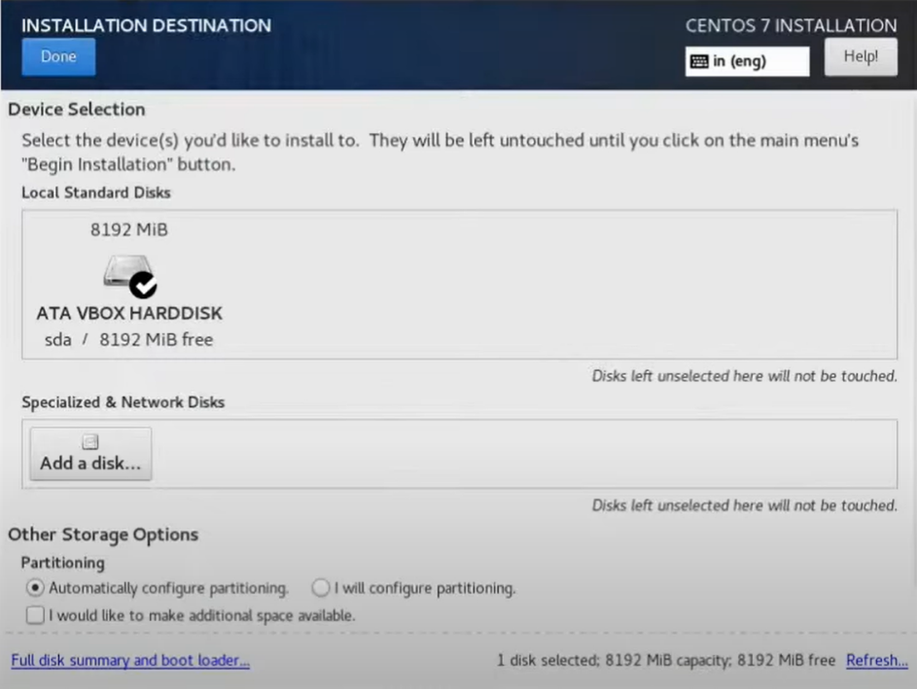
  8. The next thing you should do is go into the network and host name setting and turn on ethernet (enp0s3) A computer screen shot of a computer

     Description automatically generated
  9. You can also configure the software selection if you wanted to but otherwise click the blue begin installation button.
  10. At this point, you can now make a root password as well as create a user. Make sure to check the boxes for requiring a password and also making yourself administrator. A screenshot of a computer

      Description automatically generated
  11. The installation is now complete, you can now use CentOS.
  12. Thye next step is to now check your internet connection status. For context, This is what an unsucessful connection looks like on CentOS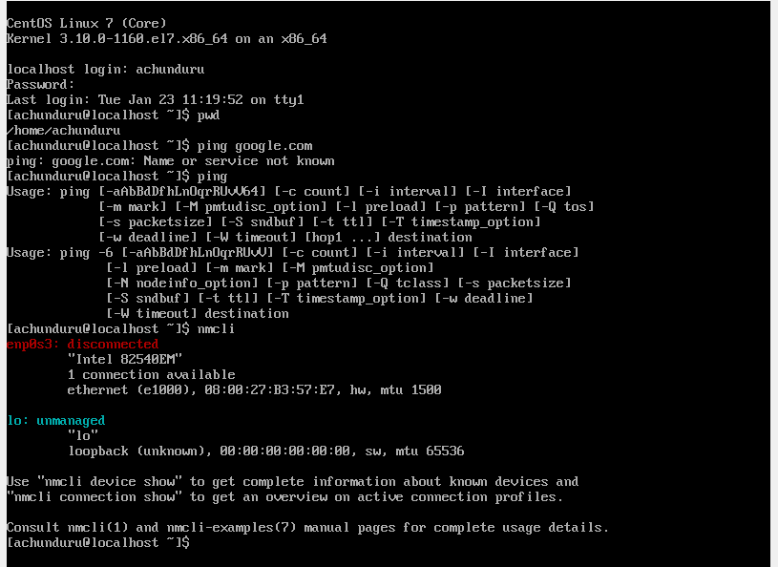
  13. This is what a successful connection looks likeA screenshot of a computer

      Description automatically generated
  14. Notes: Video memory is 128MB
  15. I made my user admin.

# **CentOS File Share**

1. **Before doing any of these steps, make sure to go to “tools” in virtual box, then properties and then go to the NAT networks tab, hit create and then give the name of your network and then enter an ipv4 address such as 192.168.100.0/24 make sure enable DHCP is checked before proceeding.**
2. On your virtual box machine, go to your settings, then network settings and from there change where it says, “attached to:”, and in the drop-down menu confirm that your adapter is attached to NAT. There you should see the name of your network.
3. Install OpenSSH on the terminal by entering in the following command: “sudo yum -y install OpenSSH-server OpenSSH-clients" in the terminal
4. check the IP addresses of your server. To do this, you need to enter in the following command: “Ip address.” Make note of this as you will need it to transfer a file over. Here’s exactly what to look for
5. The next thing to do is to enter in: scp filename user@ip_address:/home/user. Make sure to replace with actual username, ip address and path to directory. For example: A screenshot of a computer

   Description automatically generated